
Touchstones Project
Netcards

Healing Netcards with Text

Broken Watch HRJ
Church HRJ
Clown HRJ
Connecting HRJ

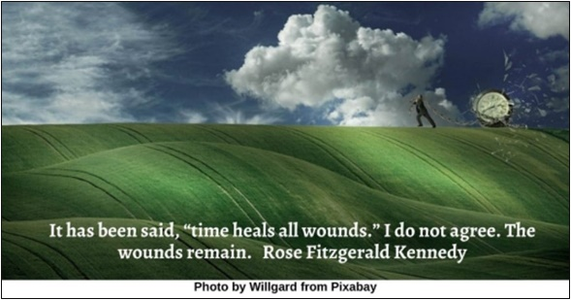

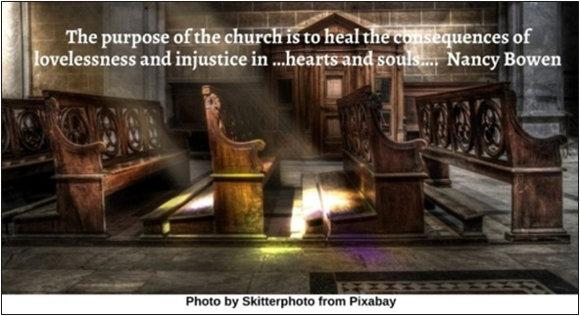

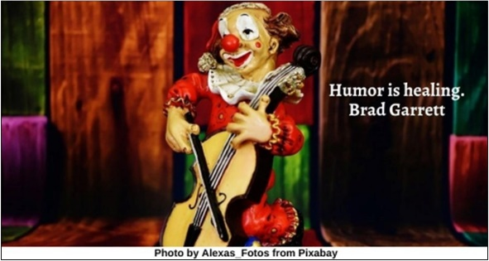

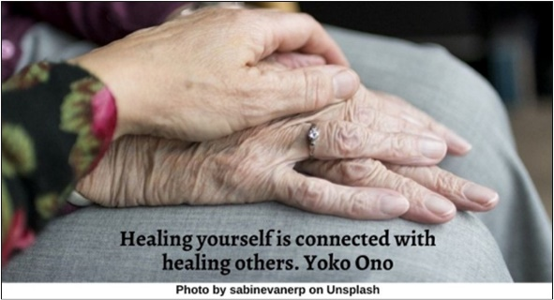

Failure HRJ
Fierce HRJ
Forgiveness HRJ
Friendship HRJ

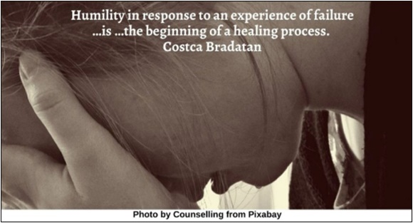

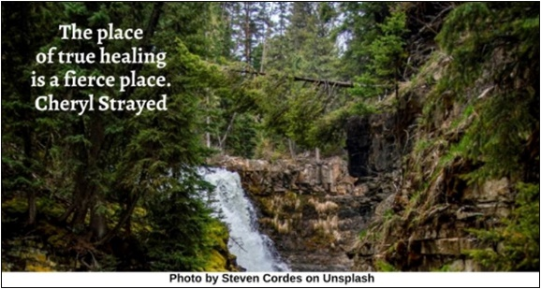

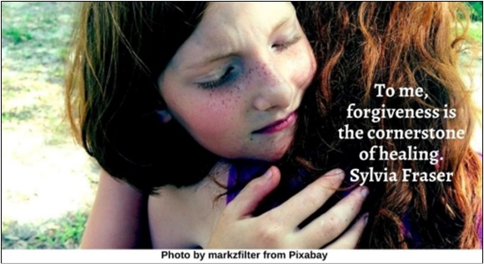

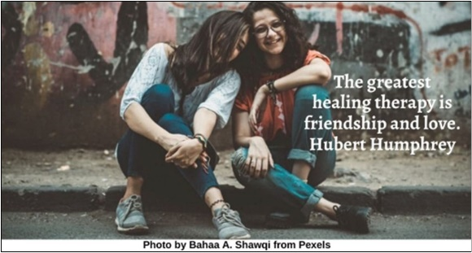

Grandparent HRJ
Grieving HRJ
Heart HRJ
Letting Go HRJ

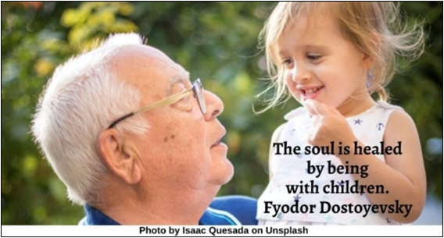

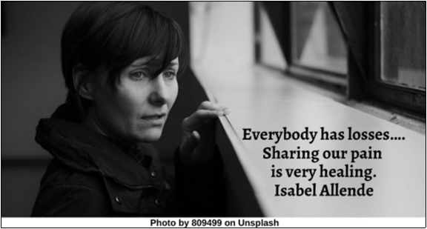

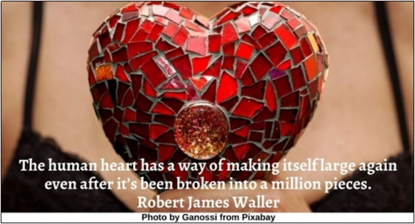

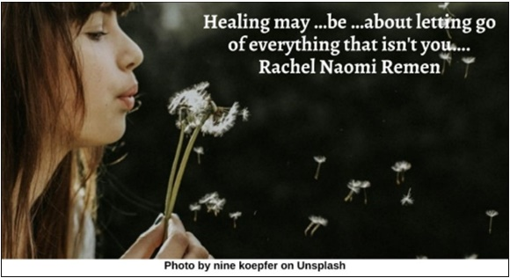

Listen HRJ
Looking in Mirror HRJ
Meditating HRJ
Mud HRJ

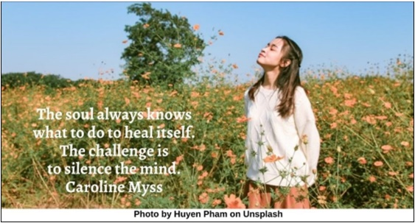

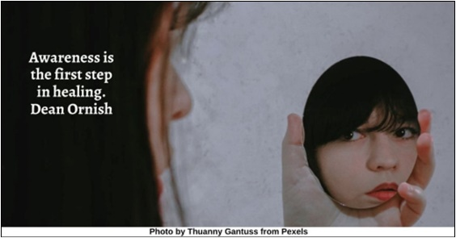

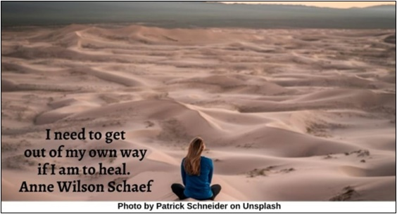

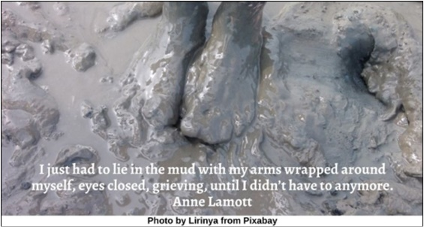

Music HRJ
Necessity HRJ
Peace HRJ
Reba McEntire HRJ

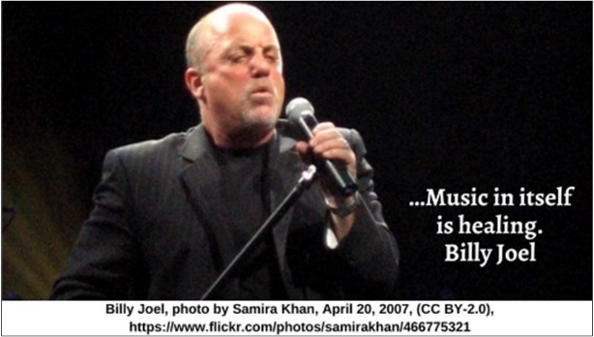

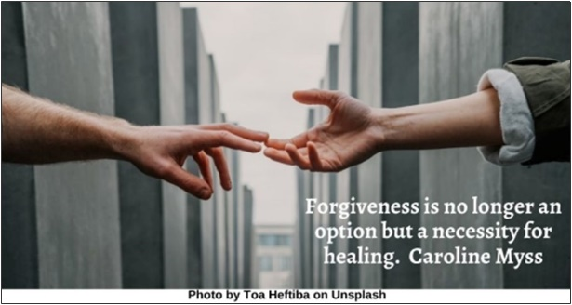

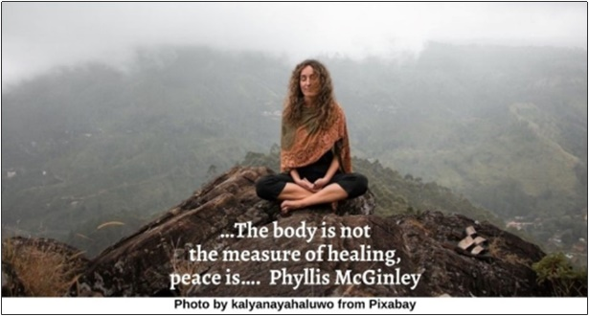

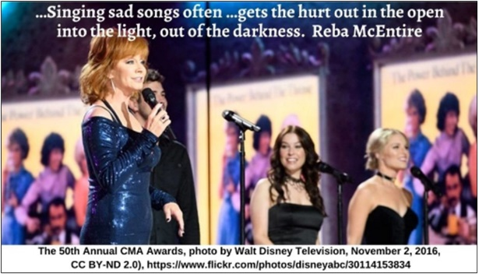

Sadness HRJ
Scars HRJ
Shovel HRJ
Stand For HRJ

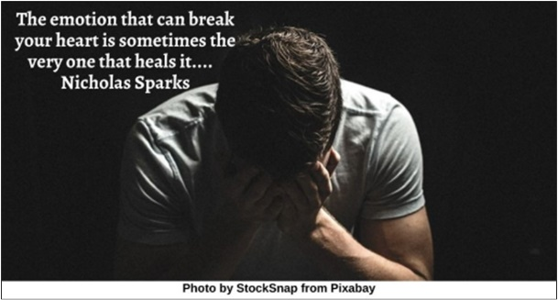

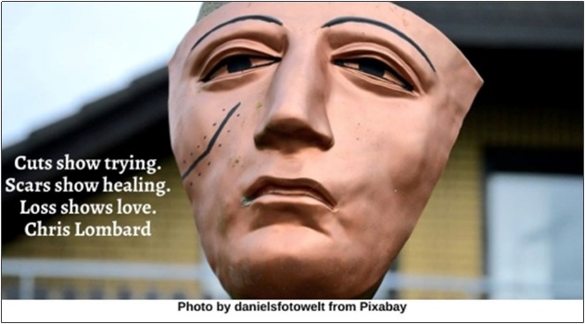

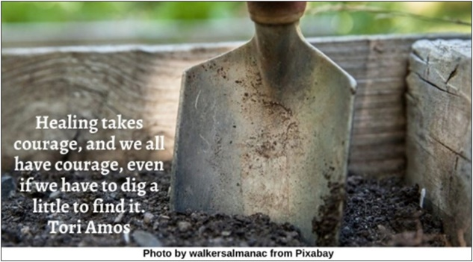

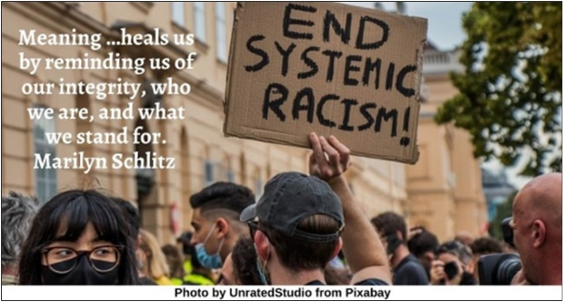

Struggle HRJ
Tears HRJ
The Blues HRJ
Touch HRJ

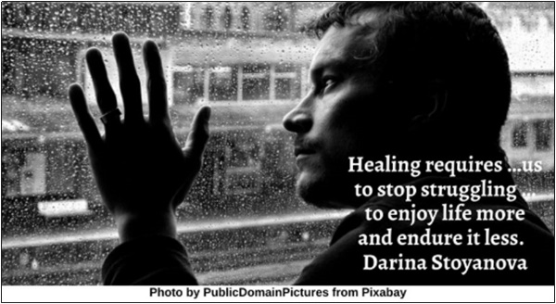

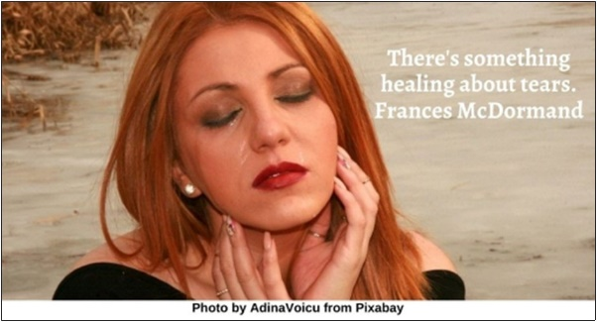

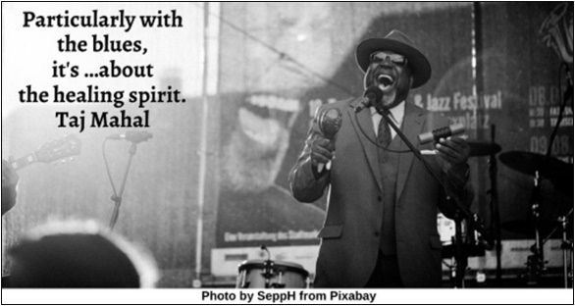

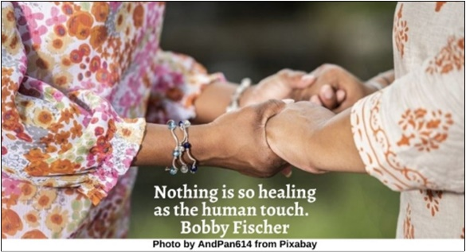

Walking HRJ
Woods HRJ
Working Together HRJ

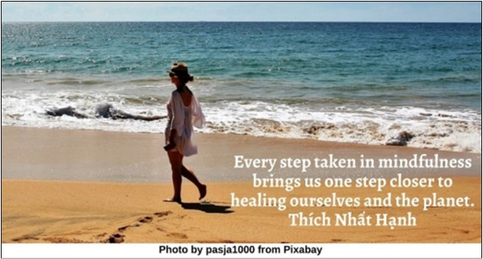

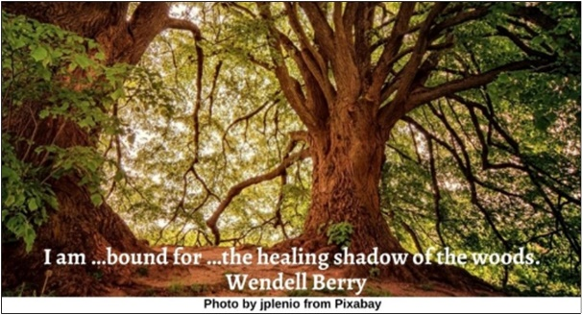

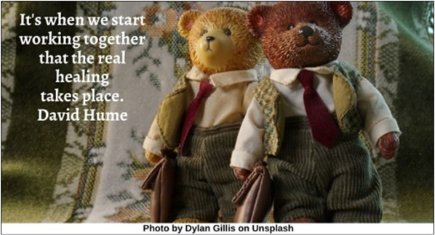

Text of Quotes
Broken Watch HRJ
It has been said, “time heals all wounds.” I do not agree. The wounds remain. Rose Fitzgerald Kennedy

Church HRJ
The purpose of the church is to heal the consequences of lovelessness and injustice in …hearts and souls…. Nancy Bowen

Clown HRJ
Humor is healing. Brad Garrett

Connecting HRJ
Healing yourself is connected with healing others. Yoko Ono

Failure HRJ
Humility in response to an experience of failure …is …the beginning of a healing process. Costca Bradatan

Fierce HRJ
The place of true healing is a fierce place. Cheryl Strayed

Forgiveness HRJ
To me, forgiveness is the cornerstone of healing. Sylvia Fraser

Friendship HRJ
The greatest healing therapy is friendship and love. Hubert H. Humphrey

Grandparent HRJ
The soul is healed by being with children. Fyodor Dostoyevsky

Grieving HRJ
Everybody has losses…. Sharing our pain is very healing. Isabel Allende

Heart HRJ
The human heart has a way of making itself large again even after it’s been broken into a million pieces. Robert James Waller

Letting Go HRJ
Healing may …be …about letting go of everything that isn't you…. Rachel Naomi Remen

Listen HRJ
The soul always knows what to do to heal itself. The challenge is to silence the mind. Caroline Myss

Looking in Mirror HRJ
Awareness is the first step in healing. Dean Ornish

Meditating HRJ
I need to get out of my own way if I am to heal. Anne Wilson Schaef

Mud HRJ
I just had to lie in the mud with my arms wrapped around myself, eyes closed, grieving, until I didn’t have to anymore. Anne Lamott

Music HRJ
…Music in itself is healing. Billy Joel

Necessity HRJ
Forgiveness is no longer an option but a necessity for healing. Caroline Myss

Peace HRJ
…The body is not the measure of healing, peace is…. Phyllis McGinley

Reba McEntire HRJ
…Singing sad songs often …gets the hurt out in the open into the light, out of the darkness. Reba McEntire

Sadness HRJ
The emotion that can break your heart is sometimes the very one that heals it.... Nicholas Sparks

Scars HRJ
Cuts show trying. Scars show healing. Loss shows love. Chris Lombard

Shovel HRJ
Healing takes courage, and we all have courage, even if we have to dig a little to find it. Tori Amos

Stand For HRJ
Meaning …heals us by reminding us of our integrity, who we are, and what we stand for. Marilyn Schlitz

Struggle HRJ
Healing requires …us to stop struggling …to enjoy life more and endure it less. Darina Stoyanova

Tears HRJ
There's something healing about tears. Frances McDormand

The Blues HRJ
Particularly with the blues, it's …about the healing spirit. Taj Mahal

Touch
Nothing is so healing as the human touch. Bobby Fischer

Walking
Every step taken in mindfulness brings us one step closer to healing ourselves and the planet. Thích Nhất Hạnh

Woods
I am …bound for …the healing shadow of the woods. Wendell Berry

Working Together HRJ
It's when we start working together that the real healing takes place. David Hume

